LONOKE HIGH SCHOOL
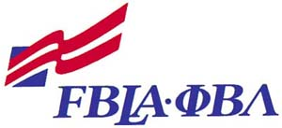
Future Business Leaders of America

2007-2008 Project Calendar
Lauren Malone, President

August
Welcome Back Faculty Breakfast (Officers)

September
FBLA Recruitment Days
Installation & Recognition Dinner
Open Arms Shelter Collection Drive
District V Fall Conference, UCA, Conway
Membership Madness Deadline

October
Fundraiser
Lonoke Literacy Council Book Drive
Red Cross Blood Drive

November
American Enterprise Workshop
FBLA National Fall Leadership Conference
Merry Thanks Partnership
Faculty Appreciation Project

December
Angel Tree Project
Christmas Social

January
March of Dimes
Chamber Chili Supper
District V Leadership Conference and Competition, UCA, Conway

February
Datamatch Fundraiser for Open Arms

March
Competitive Events Study Sessions
State Leadership Conference and Competition, Little Rock

April
Prep/Fundraise for Nationals

